

***Database Project***

|  |  |
| --- | --- |
| ***Submitted By:*** | *Shamama Aslam (sp23-bcs-143)*  *Noor Fatima (Sp23-bcs-109)* |
| ***Submitted To:*** | *Dr. Abid Sohail Bhutta* |
| ***Course :*** | *Database Management System* |
| ***Date:*** | *21-12-2024* |
| ***Section:*** | *SP23-BCS-C* |

# ***Introduction:***

In our current era of automated systems with it being either software or hardware, it’s not advisable to be using manual system. Hostels without a management system are usually done manually. Registration forms verification to other data saving processes are done manually and most at times, they are written on paper. Thus a lot of repetitions can be avoided with an automated system. The drawbacks of existing systems lead to the design of a computerized system that will help reduce a lot of manual inputs. With this system in place, we can improve the efficiency of the system, thus overcome the drawbacks of the existing manual system. This system is designed in favor of the hostel management which helps them to save the records of the students about their rooms and other things. It helps them from the manual work from which it is very difficult to find the record of the students and the mess bills of the students, and the information of about the those ones who had left the hostel years before. This system gives an idea about how a student and fee details, room allocation, mess expenditure are maintained in a better way. The hostel management system will also contain special features like how many students are in a room, student’s id and free rooms or space available. The administration has a unique identity for each member as well as students details.

***Topic Description:***

In a hostel, students or residents are provided with accommodation, and the hostel management system is designed to handle various tasks related to room allocation, payments, and overall hostel operations. The system keeps track of available rooms, room types (single, double,) and their capacity. Students are assigned rooms based on their preferences and availability. Each student's private information, as well as the room reservation details, are noted down, and the system manages check-in and check-out processes efficiently.

The hostel management system also tracks the financial side by monitoring the payments of residents. It tracks the due dates of fee payments and generates receipts for payment. The system also tracks requests for maintaining rooms and common areas. The hostel staff, wardens, and housekeeping are also tracked through the system. The system tracks information like the schedule and attendance of staff.

Besides, the system records visitor's data to maintain security and proper documentation of guest entries. The management system for hostels helps the administrator to generate reports on occupancy, payments, and maintenance to streamline hostel operations. All these features make it easier to manage daily operations, improve efficiency, and give better experience for both residents and staff.

***Database Diagram:***

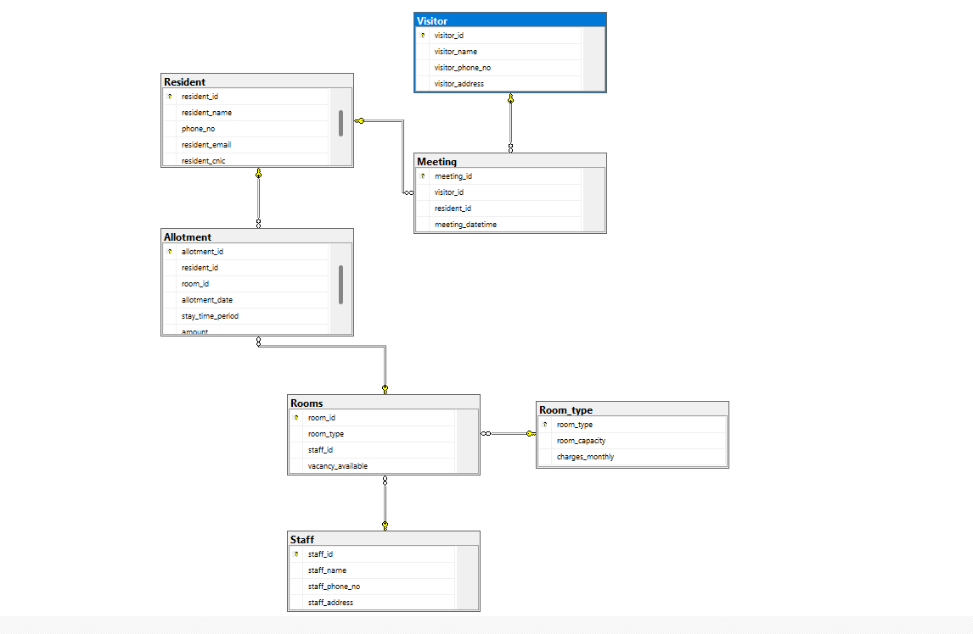

***Schema (SQL SERVER ):***

Create database Hostel

use Hostel

CREATE TABLE Resident (

resident_id INT PRIMARY KEY, resident_name VARCHAR(100), resident_phone_no VARCHAR(30),

resident_email VARCHAR(100),

resident_cnic VARCHAR(15)

);

CREATE TABLE Room_type (

room_type VARCHAR(20) PRIMARY KEY, -- Added PRIMARY KEY

room_capacity INT, -- Corrected column name capitalization

charges_monthly INT

);

CREATE TABLE Rooms (

room_id INT PRIMARY KEY,

room_type VARCHAR(20),

staff_id INT,

vacancy_available VARCHAR(20),

FOREIGN KEY (room_type) REFERENCES Room_type(room_type),

FOREIGN KEY (staff_id) REFERENCES Staff(staff_id)

);

CREATE TABLE Allotment (

allotment_id INT PRIMARY KEY,

resident_id INT,

room_id INT,

allotment_date DATE,

stay_time_period INT,

amount int,

FOREIGN KEY (resident_id) REFERENCES Resident(resident_id),

FOREIGN KEY (room_id) REFERENCES Rooms(room_id)

);

CREATE TABLE Visitor (

visitor_id INT PRIMARY KEY,

visitor_name VARCHAR(100),

visitor_phone_no VARCHAR(20),

visitor_address VARCHAR(100)

);

CREATE TABLE Meeting (

meeting_id INT PRIMARY KEY,

visitor_id INT,

resident_id INT,

meeting_datetime DATETIME,

FOREIGN KEY (resident_id) REFERENCES Resident(resident_id),

FOREIGN KEY (visitor_id) REFERENCES Visitor(visitor_id)

);

CREATE TABLE Staff (

staff_id INT PRIMARY KEY,

staff_name VARCHAR(100),

staff_phone_no VARCHAR(40),

staff_address VARCHAR(100)

);

***Insertion Code By using Faker Python:***

import pyodbc

import random

from faker import Faker

faker = Faker()

# Define your connection details

server = 'NOORAY\\SQLEXPRESS' # or use your actual server name

database = 'Hostel'

# Create the connection string with Windows Authentication

connection_string = f'DRIVER={{ODBC Driver 17 for SQL Server}};SERVER={server};DATABASE={database};Trusted_Connection=yes'

try:

# Connect to the database

connection = pyodbc.connect(connection_string)

cursor = connection.cursor()

print("Connected to the database successfully!")

# Get the current maximum resident_id from the Resident table

cursor.execute("SELECT MAX(resident_id) FROM Resident")

max_resident_id = cursor.fetchone()[0]

if max_resident_id is None:

max_resident_id = 0 # If the table is empty, start from 1

print(f"Max Resident ID: {max_resident_id}")

# Insert Resident Data (with incremented resident_id)

num_residents = 100

print("-- Inserting Resident Data")

for i in range(1, num_residents + 1):

max_resident_id += 1 # Increment resident_id

resident_query = """

INSERT INTO Resident (resident_id, resident_name, resident_phone_no, resident_email, resident_cnic)

VALUES (?, ?, ?, ?, ?);

"""

cursor.execute(resident_query, (max_resident_id, faker.name(), faker.phone_number(), faker.email(), faker.ssn()))

print(f"Inserted Resident {max_resident_id}")

# Get the current maximum staff_id from the Staff table

cursor.execute("SELECT MAX(staff_id) FROM Staff")

max_staff_id = cursor.fetchone()[0]

if max_staff_id is None:

max_staff_id = 0 # If the table is empty, start from 1

print(f"Max Staff ID: {max_staff_id}")

# Insert Staff Data (with incremented staff_id)

num_staff = 20

print("-- Inserting Staff Data")

for i in range(1, num_staff + 1):

max_staff_id += 1 # Increment staff_id

staff_query = """

INSERT INTO Staff (staff_id, staff_name, staff_phone_no, staff_address)

VALUES (?, ?, ?, ?);

"""

cursor.execute(staff_query, (max_staff_id, faker.name(), faker.phone_number(), faker.address()))

print(f"Inserted Staff {max_staff_id}")

# Get the current maximum room_id from the Rooms table

cursor.execute("SELECT MAX(room_id) FROM Rooms")

max_room_id = cursor.fetchone()[0]

if max_room_id is None:

max_room_id = 0 # If the table is empty, start from 1

print(f"Max Room ID: {max_room_id}")

# Insert Room Data (with incremented room_id)

num_rooms = 50

print("-- Inserting Room Data")

room_types = [("Single", 1, 5000), ("Double", 2, 8000), ("Triple", 3, 12000)]

for i in range(1, num_rooms + 1):

max_room_id += 1 # Increment room_id

room_type = random.choice(room_types)[0]

staff_id = random.randint(1, num_staff)

vacancy = random.choice(["Available", "Not Available"])

room_query = """

INSERT INTO Rooms (room_id, room_type, staff_id, vacancy_available)

VALUES (?, ?, ?, ?);

"""

cursor.execute(room_query, (max_room_id, room_type, staff_id, vacancy))

print(f"Inserted Room {max_room_id}")

# Get the current maximum allotment_id from the Allotment table

cursor.execute("SELECT MAX(allotment_id) FROM Allotment")

max_allotment_id = cursor.fetchone()[0]

if max_allotment_id is None:

max_allotment_id = 0 # If the table is empty, start from 1

print(f"Max Allotment ID: {max_allotment_id}")

# Insert Allotment Data (with incremented allotment_id)

num_allotments = 80

print("-- Inserting Allotment Data")

for i in range(1, num_allotments + 1):

max_allotment_id += 1 # Increment allotment_id

resident_id = random.randint(1, num_residents)

room_id = random.randint(1, num_rooms)

stay_time_period = random.randint(1, 12)

allotment_date = faker.date_this_year()

charges_monthly = random.choice(room_types)[2]

amount = charges_monthly * stay_time_period

allotment_query = """

INSERT INTO Allotment (allotment_id, resident_id, room_id, allotment_date, stay_time_period, amount)

VALUES (?, ?, ?, ?, ?, ?);

"""

cursor.execute(allotment_query, (max_allotment_id, resident_id, room_id, allotment_date, stay_time_period, amount))

print(f"Inserted Allotment {max_allotment_id}")

# Commit the transaction

connection.commit()

print("Data inserted successfully!")

except Exception as e:

print(f"An error occurred: {e}")

finally:

if 'connection' in locals() and connection:

connection.close()

print("Database connection closed.")

RESULTS :

**REPORTS :**

***Procedures*:**

1. **MonthlyOccupancyReport:**

The stored procedure calculates the monthly occupancy report for rooms in a hotel or accommodation setup. It takes two input parameters: @month and @year, which define the specific month and year for which the occupancy report is generated.

* **Query :**

CREATE PROCEDURE sp_MonthlyOccupancyReport

@month INT,

@year INT

AS

BEGIN

SELECT

r.room_type,

COUNT(a.room_id) as occupied_rooms,

rt.room_capacity * COUNT(DISTINCT r.room_id) as total_capacity,

CAST(COUNT(a.room_id) * 100.0 / COUNT(DISTINCT r.room_id) AS DECIMAL(5,2)) as occupancy_rate

FROM Rooms r

LEFT JOIN Allotment a ON r.room_id = a.room_id

JOIN Room_type rt ON r.room_type = rt.room_type

WHERE MONTH(a.allotment_date) = @month

AND YEAR(a.allotment_date) = @year

GROUP BY r.room_type, rt.room_capacity;

END;

Execution:

EXEC sp_MonthlyOccupancyReport @month=12, @year=2024;

**2- RevenueByRoomType:**

The stored procedure is designed to calculate the total revenue, total allotments, and average revenue per allotment for each room type within a specified date range. The procedure takes two input parameters: @start_date and @end_date, which define the date range for which the report will be generated.

* **Query**:

CREATE PROCEDURE sp_RevenueByRoomType

@start_date DATE,

@end_date DATE

AS

BEGIN

SELECT

r.room_type,

COUNT(DISTINCT a.allotment_id) as total_allotments,

SUM(a.amount) as total_revenue,

AVG(a.amount) as avg_revenue_per_allotment

FROM Allotment a

JOIN Rooms r ON a.room_id = r.room_id

WHERE a.allotment_date BETWEEN @start_date AND @end_date

GROUP BY r.room_type

ORDER BY total_revenue DESC;

END;

EXECUTION

EXEC sp_RevenueByRoomType @start_date = '2024-01-01', @end_date = '2024-12-31';

**3- StaffPerformanceReport:**

The stored procedure is designed to generate a report that evaluates the performance of hotel staff based on the number of rooms managed, the total allotments (bookings) handled, and the revenue generated by those allotments.

* **QUERY**:

cREATE PROCEDURE sp_StaffPerformanceReport

AS

BEGIN

SELECT

s.staff_id,

s.staff_name,

COUNT(DISTINCT r.room_id) as rooms_managed,

COUNT(DISTINCT a.allotment_id) as total_allotments,

SUM(a.amount) as revenue_generated

FROM Staff s

LEFT JOIN Rooms r ON s.staff_id = r.staff_id

LEFT JOIN Allotment a ON r.room_id = a.room_id

GROUP BY s.staff_id, s.staff_name;

END;

EXECUTION:

EXEC sp_StaffPerformanceReport

***VIEWS***

**1-ResidentStayAnalysis**:

The view is designed to analyze the stay details of residents in a hotel or accommodation setup. It provides a comprehensive report about each resident’s stay, total stay days, total money spent, and the date of their most recent stay. This view combines data from the Resident table (which holds resident details) and the Allotment table (which tracks individual stays and bookings).

* **QUERY**:

CREATE VIEW vw_ResidentStayAnalysis AS

SELECT

res.resident_id,

res.resident_name,

COUNT(DISTINCT a.allotment_id) as total_stays,

SUM(a.stay_time_period) as total_stay_days,

SUM(a.amount) as total_spent,

MAX(a.allotment_date) as last_stay_date

FROM Resident res

LEFT JOIN Allotment a ON res.resident_id = a.resident_id

GROUP BY res.resident_id, res.resident_name;

Execution:

**2- MonthlyRevenue**

The view is designed to provide a monthly revenue report for each room type. It aggregates the total revenue, the number of allotments (bookings), and the average revenue per allotment for each room type within each month. This view uses the Allotment table to track the bookings and the Rooms table to identify the type of room booked

* **QUERY**:

CREATE VIEW vw_MonthlyRevenue AS

SELECT

FORMAT(a.allotment_date, 'yyyy-MM') AS month,

r.room_type,

COUNT(DISTINCT a.allotment_id) AS total_allotments,

SUM(a.amount) AS total_revenue,

AVG(a.amount) AS avg_revenue_per_allotment

FROM Allotment a

JOIN Rooms r ON a.room_id = r.room_id

GROUP BY FORMAT(a.allotment_date, 'yyyy-MM'), r.room_type;

EXECUTION:

**3-VisitorActivity:**

The view is designed to provide a summary of the activity of visitors who meet residents in a hotel or accommodation setting. It aggregates information such as the total number of meetings a visitor has attended, the first and last meeting dates, and the resident they visited.

* **QUERY**:

CREATE VIEW vw_VisitorActivity AS

SELECT

v.visitor_id,

v.visitor_name,

res.resident_name AS visited_resident,

COUNT(m.meeting_id) AS meeting_count,

MAX(m.meeting_datetime) AS last_visit,

MIN(m.meeting_datetime) AS first_visit

FROM Visitor v

JOIN Meeting m ON v.visitor_id = m.visitor_id

JOIN Resident res ON m.resident_id = res.resident_id

GROUP BY v.visitor_id, v.visitor_name, res.resident_name;

EXECUTION:

Select * from vw_VisitorActivity

***Materialized View***

1- MonthlyRevenue

The view is designed to provide a detailed report on the monthly revenue generated from residents, broken down by room type. It calculates the total revenue, the number of residents, and the average revenue per resident for each month and room type. The ROLLUP clause adds summary rows, which include aggregates for each month and overall totals across all months.

QUERY :

CREATE VIEW vw_MonthlyRevenueDenorm AS

SELECT

YEAR(allotment_date) as year,

MONTH(allotment_date) as month,

room_type,

COUNT(DISTINCT resident_id) as total_residents,

SUM(total_amount) as total_revenue,

AVG(total_amount) as avg_revenue_per_resident

FROM resident_denormalized

GROUP BY YEAR(allotment_date), MONTH(allotment_date), room_type

WITH ROLLUP;

SELECT * FROM vw_MonthlyRevenueDenorm;

***History table***

CREATE TABLE Resident_History (

history_id INT IDENTITY(1,1) PRIMARY KEY,

resident_id INT,

resident_name VARCHAR(100),

resident_phone_no VARCHAR(30),

resident_email VARCHAR(100),

resident_cnic VARCHAR(15),

action_type VARCHAR(10),

action_date DATETIME,

action_by VARCHAR(100)

);

CREATE TABLE Allotment_History (

history_id INT IDENTITY(1,1) PRIMARY KEY,

allotment_id INT,

resident_id INT,

room_id INT,

allotment_date DATE,

stay_time_period INT,

amount INT,

action_type VARCHAR(10),

action_date DATETIME,

action_by VARCHAR(100))

Procedures for insertion/updating/deletion

* **AddNewResident (INSERTION)**

he sp_AddNewResident stored procedure is designed to add a new resident to the system and assign them to a room. It performs several actions in a single transaction:

1-Adds a new resident to the Resident table.

2-Creates an allotment for the resident by assigning them to a room in the Allotment table.

3-Updates the room status in the Rooms table to mark it as "No" for available vacancy, indicating that the room is now occupied.

The procedure ensures that all actions are executed as a single transaction. If an error occurs at any point during the execution, all changes are rolled back, maintaining the integrity of the data.

**QUERY**:

CREATE PROCEDURE sp_AddNewResident

@name VARCHAR(100),

@phone VARCHAR(30),

@email VARCHAR(100),

@room_id INT

AS

BEGIN TRY

BEGIN TRANSACTION;

INSERT INTO Resident (resident_name, resident_phone_no, resident_email)

VALUES (@name, @phone, @email)

INSERT INTO Allotment (resident_id, room_id, allotment_date)

VALUES (SCOPE_IDENTITY(), @room_id, GETDATE());

UPDATE Rooms SET vacancy_available = 'No'

WHERE room_id = @room_id;

COMMIT;

END TRY

BEGIN CATCH

ROLLBACK;

PRINT 'Error: ' + ERROR_MESSAGE();

END CATCH;

**2-Change room (Updation):**

The sp_ChangeRoom stored procedure allows for the relocation of a resident from their current room to a new room. It performs the following actions:

1-Updates the availability of the current room: It marks the resident's current room as available (vacancy set to "Yes").

2-Updates the allotment record: It updates the Allotment table to reflect the new room assignment for the resident.

3-Updates the availability of the new room: It marks the new room as occupied (vacancy set to "No").

**QUERY**:

CREATE PROCEDURE sp_ChangeRoom

@resident_id INT,

@new_room_id INT

AS

BEGIN TRY

BEGIN TRANSACTION;

UPDATE Rooms

SET vacancy_available = 'Yes'

WHERE room_id = (

SELECT room_id

FROM Allotment

WHERE resident_id = @resident_id

);

UPDATE Allotment

SET room_id = @new_room_id

WHERE resident_id = @resident_id;

UPDATE Rooms

SET vacancy_available = 'No'

WHERE room_id = @new_room_id;

COMMIT;

END TRY

BEGIN CATCH

ROLLBACK;

PRINT 'Error: ' + ERROR_MESSAGE();

END CATCH;

3- Resident checkout :

The sp_CheckOutResident stored procedure is designed to handle the checkout process for a resident, which involves the following actions:

1-Freeing up the room: It updates the room's availability status to mark the room as vacant (set to 'Yes').

2-Removing the allotment record: It deletes the resident's allotment entry in the Allotment table, indicating that the resident is no longer assigned to the room.

3-Deleting the resident record: It deletes the resident's record from the Resident table, effectively removing them from the system.

**QUERY**:

CREATE PROCEDURE sp_CheckOutResident

@resident_id INT

AS

BEGIN TRY

BEGIN TRANSACTION;

UPDATE Rooms

SET vacancy_available = 'Yes'

WHERE room_id = (

SELECT room_id

FROM Allotment

WHERE resident_id = @resident_id

);

DELETE FROM Allotment

WHERE resident_id = @resident_id;

DELETE FROM Resident

WHERE resident_id = @resident_id;

COMMIT;

END TRY

BEGIN CATCH

ROLLBACK;

PRINT 'Error: ' + ERROR_MESSAGE();

END CATCH;